Practical 7:
PHP Form Processing with Server-Side Validation and CSV/JSON File Storage
Problem Definition :
Process submitted registration/contact form data using PHP. Validate and sanitize inputs on the server side and store records in CSV or JSON file
format. Display success/error

Key Questions / Analysis
1. Is the form submitted using POST?
Yes. The form uses method="POST" to send data securely to the PHP file.
2. Are inputs validated and sanitized server side?
Yes. PHP checks empty fields and validates the email. htmlspecialchars() is used to sanitize the input.
3. Is file writing handled safely?
Yes. The CSV file is opened using fopen() in append mode, data is written using fputcsv(), and the file is closed using fclose().
4. Are success and error responses displayed clearly?
Yes. Clear messages such as "Registration Successful!", "Please fill all fields.", and "Invalid email address." are displayed.

Implementation/out put/result:

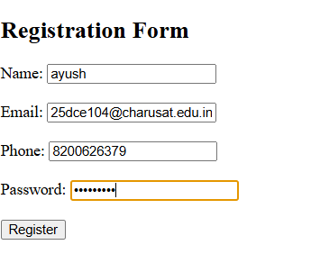

Git hub link:
https://github.com/Ayushsavaliya0305/25dce104-web/tree/main/practical%207

Learning Outcomes
- Understand how to process HTML forms using PHP.
- Learn to use the POST method for submitting form data.
- Perform server-side validation and sanitization.
- Learn to store form data in a CSV file using PHP.
- Display clear success and error messages.

Faculty remarks:

